Lab 02 – Introduction to User Input and Output, Variables, Operators and
August 28, 2026 Problem-Solving using Decision and Iterative Structures using Scratch Programming
Student Name: ______LUBNA MEMON_____________________ Roll No: _26K-0659_______________ Section: BCS-1D

Question:1
Create a program that acts as a simple shopping cart calculator. Ask the user for the price of an item and the quantity they want to buy. The program should finally tell the user the total amount they owe.
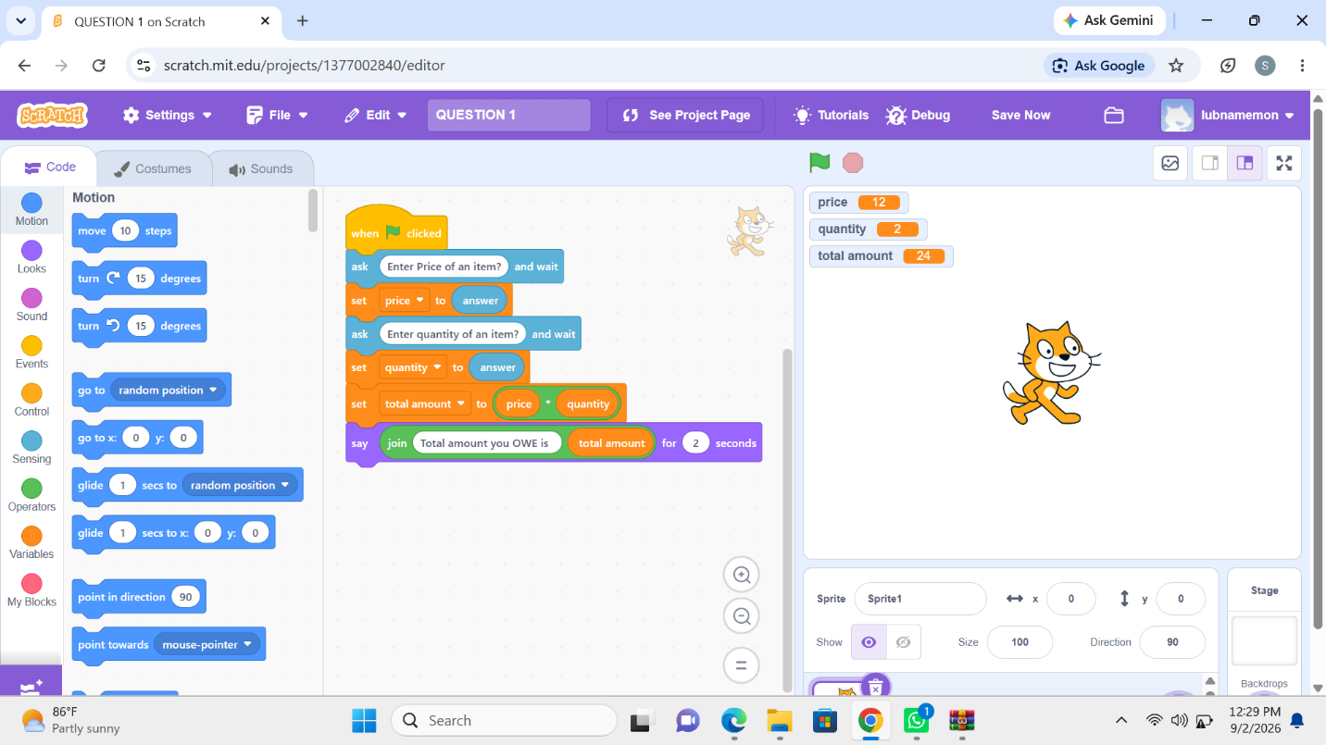
Question:2
Create a program that determines if a year is a leap year. Ask the user to enter a year. A year is a leap year if it meets one of these conditions:
It's evenly divisible by 4 but not by 100.
It's evenly divisible by 400.
The program should say "is a leap year!" or "is not a leap year!" depending on the result.
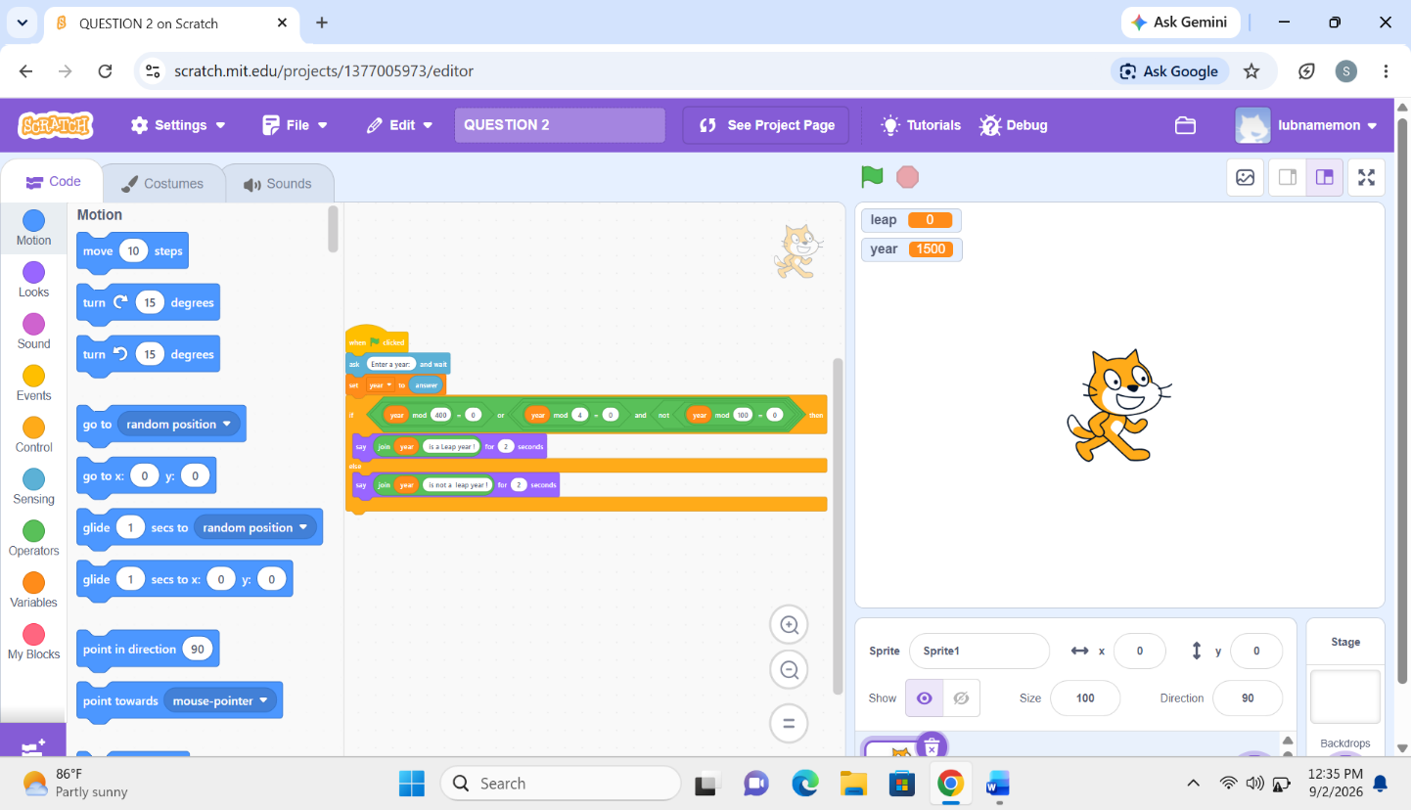

Question: 3
Make a program that generates and displays the first 10 numbers of the Fibonacci sequence. The sequence starts with 0 and 1, and each subsequent number is the sum of the two preceding ones (e.g., 0, 1, 1, 2, 3, 5, 8, 13,12). calculate and show each number.
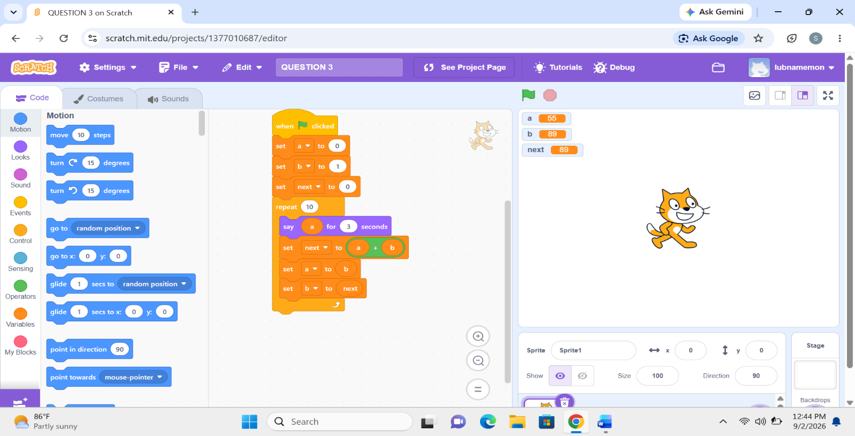

Question: 4
Create a program that asks the user to input the total bill amount, calculates a 5% tip on that amount, adds the tip to the original bill, and finally displays the original bill, tip amount, and final total

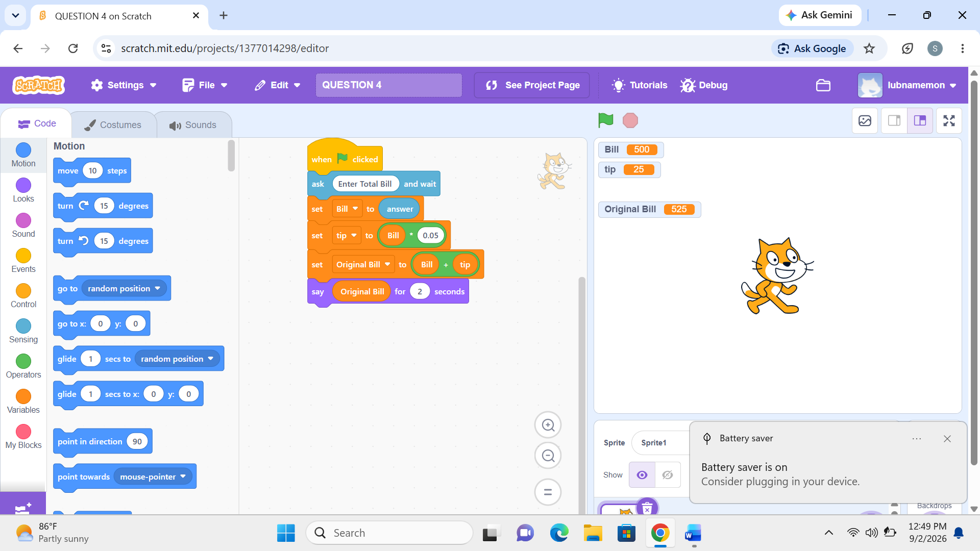

Question: 5
Create a program that calculates the final price of an item after applying a 20% discount. Show the final price after applying a discount

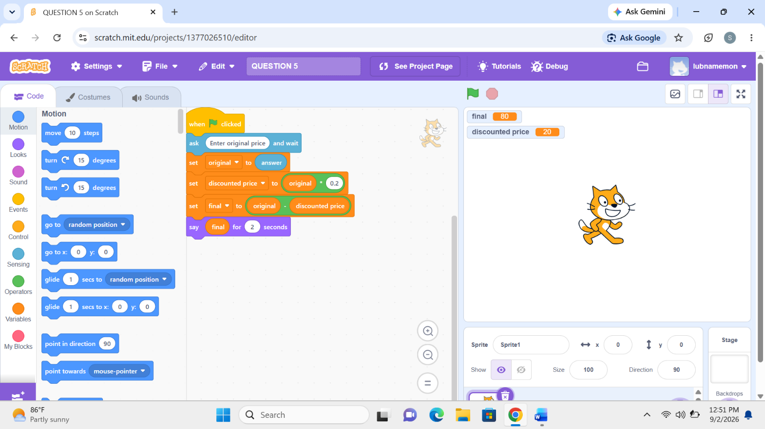

Question 6:
Create a game where the computer randomly chooses a number between 1 and 20. The user has only 5 chances to guess it. If they guess correctly, the sprite says “You win!” Otherwise, after 5 wrong guesses, the sprite says “Game Over.

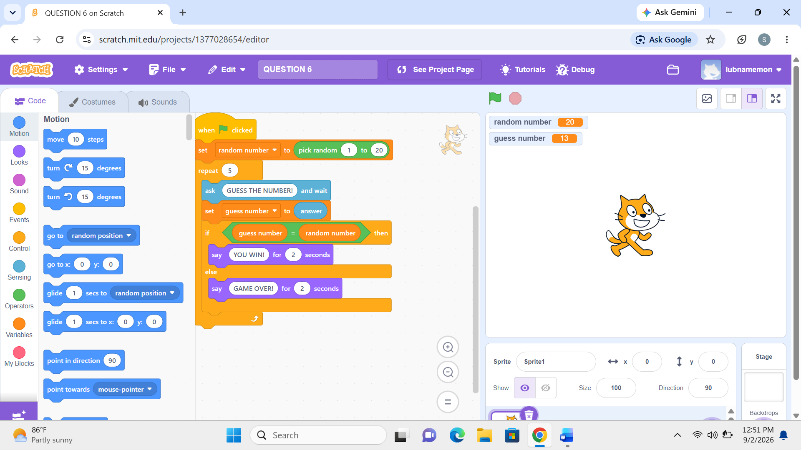

Prepared By: Miss Izzah Salam | Introduction to Programming Fundamentals 1

Lab 02 – Introduction to User Input and Output, Variables, Operators and
August 28, 2026 Problem-Solving using Decision and Iterative Structures using Scratch Programming
Student Name: ___________________________ Roll No: ________________ Section: BCS-1D

Question 7:
Make a program where the sprite asks for 3 numbers and then says the smallest number among them.
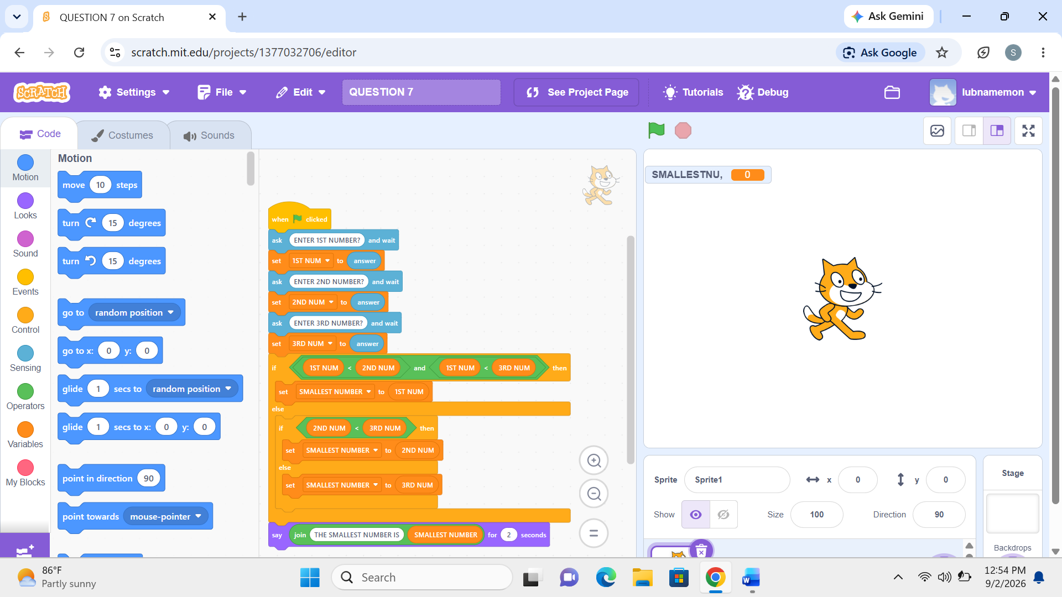
Question 8:
Create a program for a vending machine. Ask the user for an item number (1, 2, or 3).
For "1," say "Here is your chocolate bar."
For "2," say "Here is your soda."
For "3," say "Here are your chips."
If the user enters anything else, say "Item not available."
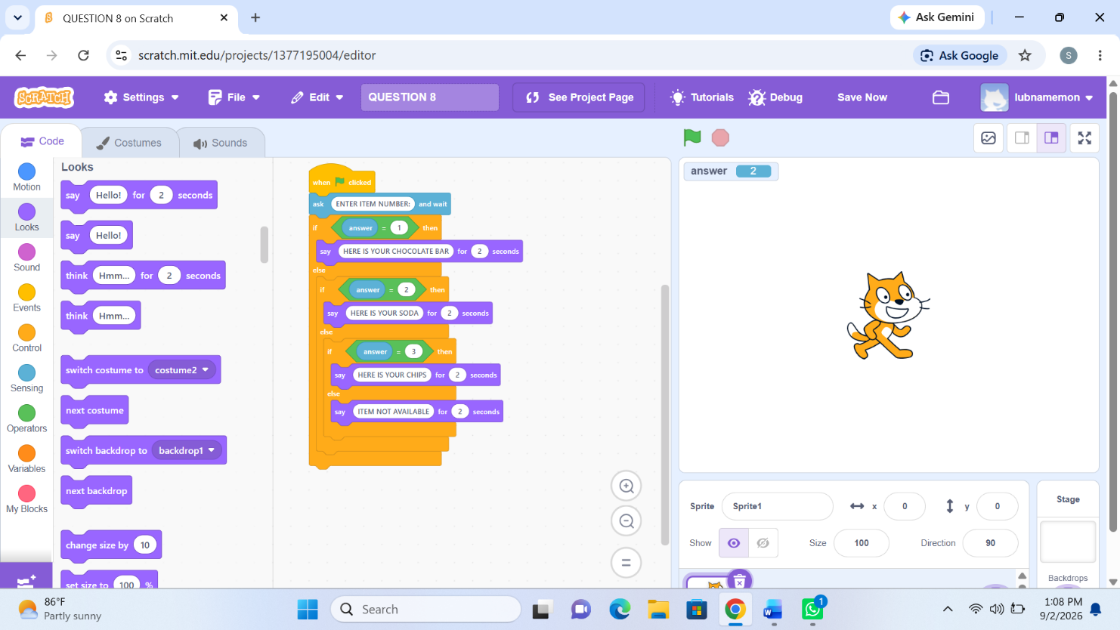

Question 9:
Write a program that shows the square of numbers from 1 to 10. (Example: it should show 1, 4, 9, 16 … up to 100).
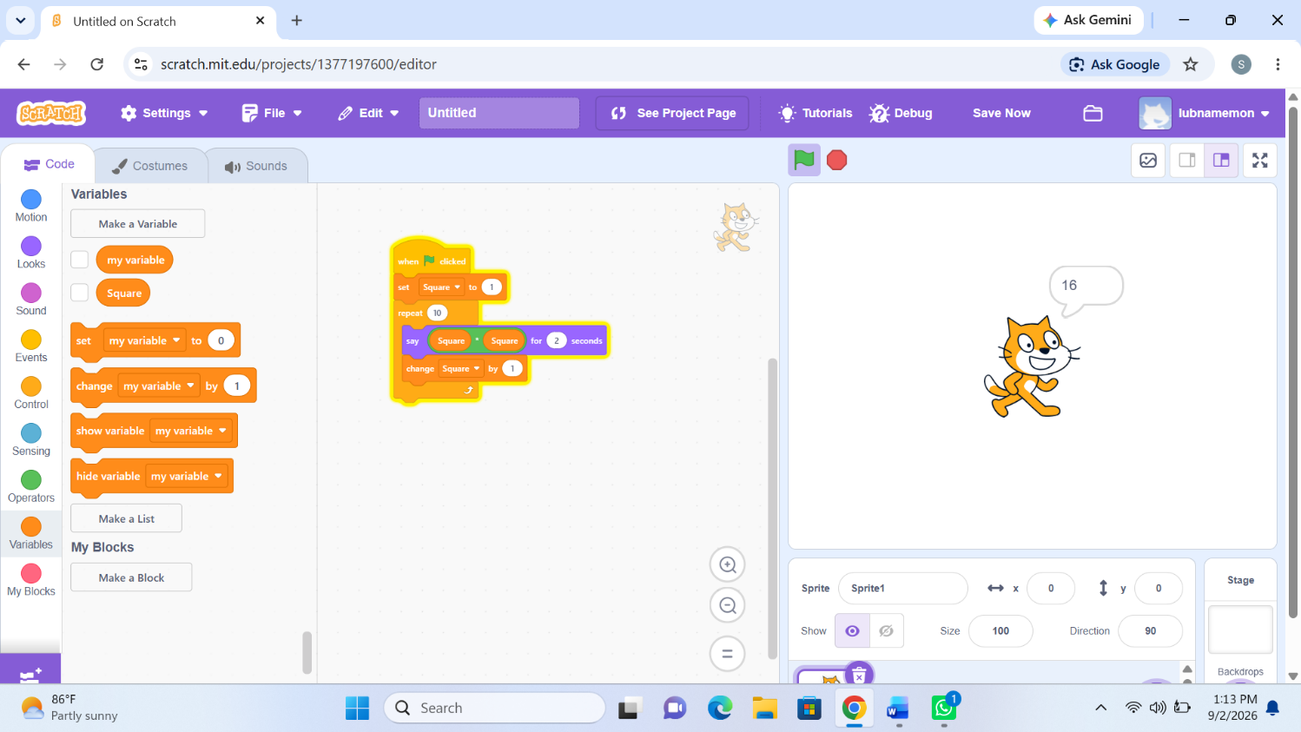

Question 10:
Create a program that asks the user to enter three different numbers. At the end of the program, the sprite should say which number was the highest and which was the lowest.
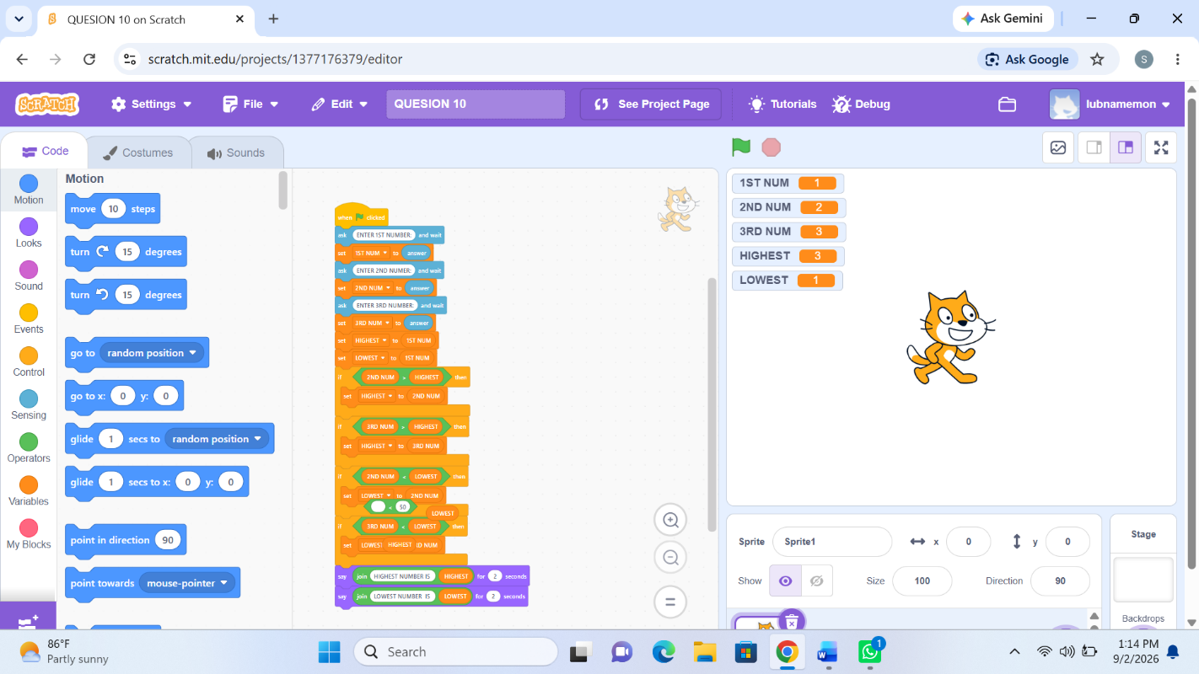

Prepared By: Miss Izzah Salam | Introduction to Programming Fundamentals 2

